Lenna Kovalevich

Bio 471 Homework #2

1. (Handwritten- submitted as picture)

2a.

log.growth <- function(t, y, p) {

N <- y[1]

with(as.list(p), {

dN.dt <- r * N * (1 - (N / K)^theta)

return(list(dN.dt))

})

}

p <- c('r'= 0.25, 'K'= 100, 'theta' = 1)

y0 <- c('N' = runif(1, min=0.01, max=0.1))

t <- 1:100

sim <- ode(y = y0, times = t, func = log.growth, parms = p,

method = 'lsoda')

sim <- as.data.frame(sim)

2b. (Continued from above)

sim$deriv <- c(diff(sim$N), NA)

plot(deriv ~ N, data = sim, type = 'l', col = 'blue', bty ='l')

p.2 <- c('r' = 0.25, 'K' = 50, 'theta' = 1)

sim.2 <- ode(y = y0, times=t, func= log.growth, parms = p.2,

method = 'lsoda')

sim.2 = as.data.frame(sim.2)

sim.2$deriv <- c(diff(sim.2$N), NA)

points (deriv ~ time, data= sim.2, type = 'l', col='purple')

class(sim.2)

p.3 <- c('r' = 0.25, 'K' = 25, 'theta' = 1)

sim.3 <- ode(y = y0, times=t, func= log.growth, parms = p.3,

method = 'lsoda')

sim.3 = as.data.frame(sim.3)

sim.3$deriv <- c(diff(sim.3$N), NA)

points (deriv ~ time, data= sim.3, type = 'l', col='green')

class(sim.3)

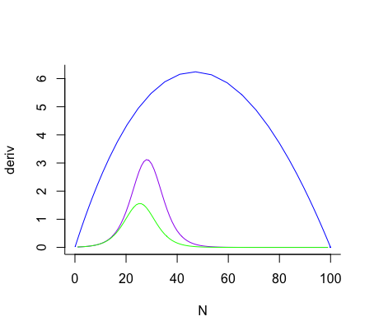

2c.

max(sim$deriv, na.rm = TRUE)

which(sim$derive == max(sim$deriv, na.rm = TRUE))

sim$N[which(sim$deriv == max(sim$deriv, na.rm = TRUE))]

- The answer given here is **45.3715.**

sim.2$N[which(sim.2$deriv == max(sim.2$deriv, na.rm = TRUE))]

- The answer given here is **21.99517.**

sim.3$N[which(sim.3$deriv == max(sim.3$deriv, na.rm = TRUE))]

- The answer given here is **12.20969.**

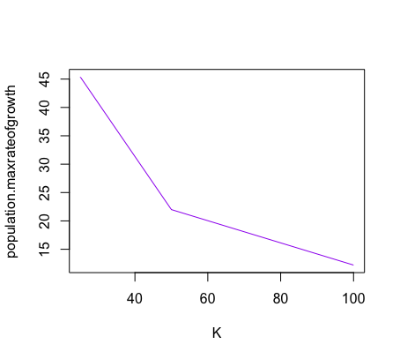

3.

## QUESTION 3

p.a <- c('r' = 0.25, 'K' = 100, 'theta'= 0.5)

p.b <- c('r' = 0.25, 'K' = 100, 'theta'= 1)

p.c <- c('r' = 0.25, 'K' = 100, 'theta'= 1.8)

install.packages('deSolve')

library(deSolve)

sim.a <- ode (y = y0, times=t, func= log.growth, parms = p.a, method= 'lsoda')

sim.a <- as.data.frame(sim.a)

sim.b <- ode (y = y0, times=t, func= log.growth, parms = p.b, method= 'lsoda')

sim.b <- as.data.frame(sim.b)

sim.c <- ode (y = y0, times=t, func= log.growth, parms = p.c, method= 'lsoda')

sim.c <- as.data.frame(sim.c)

sim.a$deriv <- c(diff(sim.a$N), NA)

sim.b$deriv <- c(diff(sim.b$N), NA)

sim.c$deriv <- c(diff(sim.c$N), NA)

max(sim$deriv, na.rm = TRUE)

which(sim$derive == max(sim$deriv, na.rm = TRUE))

##44.30202

max(sim.b$deriv, na.rm = TRUE)

which(sim.b$derive == max(sim.b$deriv, na.rm = TRUE))

##6.23/ integer 0

max(sim.c$deriv, na.rm = TRUE)

which(sim.c$derive == max(sim.c$deriv, na.rm = TRUE))

##9.041893/ integer 0

SPECIES A!!!!

4. (Handwritten- submitted as picture)